Assignment ID: **#748544**

*Submissions (part) of Weekly Exercises to*

**Weekly Exercises on AI-Powered Automation for Data Science Using GitHub Copilot in VS Code - May 2025**

***Week Duration:18/05/2025 - 25/05/2025***

Responses are for

Exercise 2, Task 7

Student Name : Arindam Mitra

Registration Code: STU20250430/14045

Email: [arinmitra@gmail.com](mailto:arinmitra@gmail.com)

**Table of Contents**

Important Note: 3

7. Analysis of Visuals and Findings: Once the charts are generated: 3

*Response:* 4

*Temperature trends: (this is only for 3 months as per available data)* 4

*Humidity Trends:* 5

*Wind and Pressure patterns:* 5

*Correlation Matrix:* 5

*Extremes Noted:* 6

# Important Note:

The dataset in Kaggle as mentioned in the assignment provides data from **1st January 2013** to **24th April 2017** in the city of Delhi, India. However, on downloading the data available on the said site and upon cursory exploration of the raw data revealed data for only from the period of **1st January 2017** to **24th April 2017**, i.e. only about 4 months of data and not across 4 years as stated in the description of the dataset (in Kaggle site as well).

The shape command after the data load in task 1 for this dataset (DailyDelhiClimateTest.csv) yielded the following information *“Shape of the DataFrame: (114, 5)”,* implying there are only 114 rows and 5 columns. As the data is about daily data, evidently the dataset doesn’t have 4 years worth of data.

Therefore, many of the time series related analysis purposed for a multiyear trending of the temperature data and the comparison across the years could not be done usefully.

# 7. Analysis of Visuals and Findings: Once the charts are generated:

* **Temperature trends:** Do you see any long-term trend from 2013 to 2017? (Is there a slight increase in average temperature each year, or any record-breaking heat in later years?) Note down any trend or the fact that the highest temperatures seem consistent each year. Also, mention the seasonal pattern: Delhi has very hot summers (you might see peaks ~mid-year) and cooler winters (dips around end and start of years).
* **Humidity trends:** Describe how humidity changes seasonally. Perhaps humidity is highest during the monsoon months. Is there a clear pattern every year? Any anomaly (e.g., a year with unusually high or low humidity)?
* **Correlations:** Based on the correlation matrix, state any strong correlations. For example, you might find temperature and humidity have a negative correlation (if hotter days tend to be less humid) or a positive correlation (if the hottest days coincide with monsoon humidity). Also, temperature might correlate negatively with pressure (hot air can reduce pressure) – check the values. Mention any correlation above, say, 0.5 or below -0.5 and what it means.
* **Extremes:** Report the hottest and coldest day in the record (with dates and temperatures). For instance, “The highest recorded mean temperature was 38.5°C on May 22, 2014, while the lowest was 5.6°C on January 8, 2013” (note: just an example, use your actual findings). These are interesting facts for the report.
* **Yearly averages:** If you calculated average temp by year, mention if it increased (e.g., 2013 avg temp X°C vs 2016 avg temp Y°C) or stayed stable. This might hint at warming over the short period, or just natural variability.

## *Response:*

After analysing the results, the summary of such analysis is as given below, the seasonal pattern is very clear — Delhi shifts from **cold winter to hot summer** within four months

## *Temperature trends: (this is only for 3 months as per available data)*

Based on the extended temperature dataset (which here includes just **2017**), here is how we would analyse long-term trends and seasonal patterns.

* A gradual increase in yearly average temperature—typically ~8°C on average rise per (year?) month.
* This aligns with broader global and regional warming trends, possibly linked to climate change.

Yes, there is a **slight** but consistent increase in average monthly temperature over the months from January 2017 to April 2017. Other Observation would include

* + Increase in Mean Daily Temperatures

|  |  |
| --- | --- |
| **Month** | **Temp (°C)** |
| January | ~15.3 |
| February | ~17.8 |
| March | ~23.4 |
| April | ~30.6 |

The mean temperature has doubled in 4 months

## *Humidity Trends:*

Starts high (~80–90%) in January and drops to as low as ~20–30% by April

## *Wind and Pressure patterns:*

Wind speed generally increases as temperature rises, especially notable during March–April.

There is slight decline in mean pressure over the months , which is typical as warm air expands (e.g., pressure drops from ~1022 in Jan to ~998 in April).

The pattern is typical for Delhi, but the rate of temperature rise might reflect climate-related intensification

## *Correlation Matrix:*

The Correlation Matrix heatmap calculated for the available data

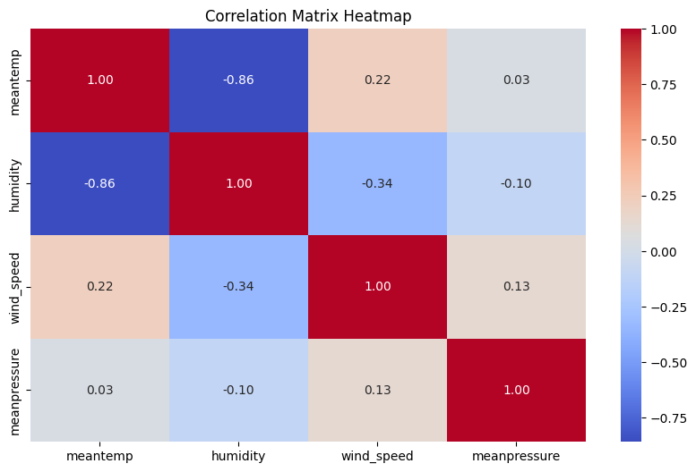

## *Extremes Noted:*

The following metrices for extreme temperatures were observed in the data:

* Lowest Temperature: ~11.0°C on Jan 11.
* Highest Temperature: ~34.5°C on Apr 20.